HELP ME I can’t see!

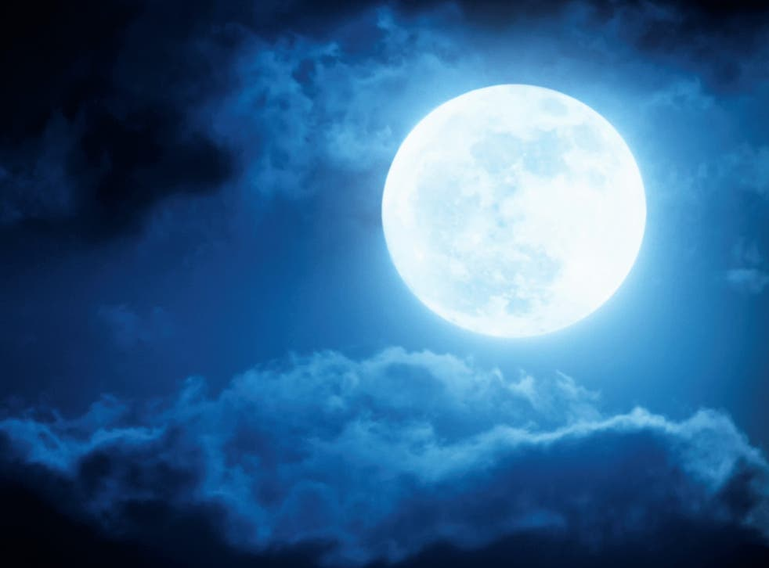

Its dark I can’t see anything please open the light:

JUFlag{open_the_light}